Git Url:

<https://github.com/AdityaSP/itc-aug26-jenkins>

**Docs.ansible.com/**

**Git location for ansible docs:**

<https://github.com/AdityaSP/itc-aug26-jenkins>



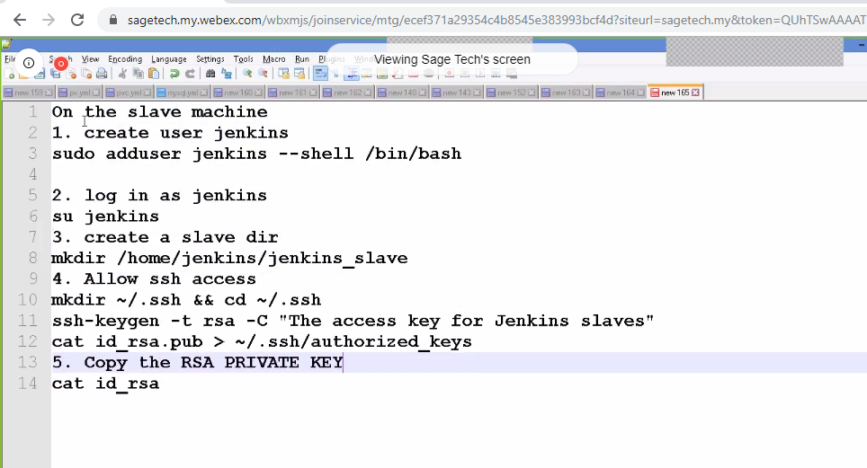

Manage Jenkins🡪Manage Nodes🡪Create a new node

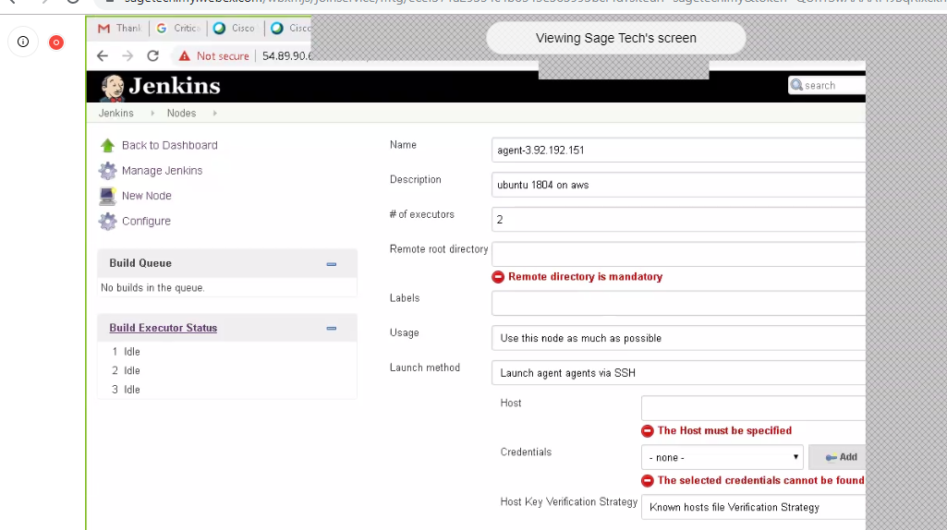

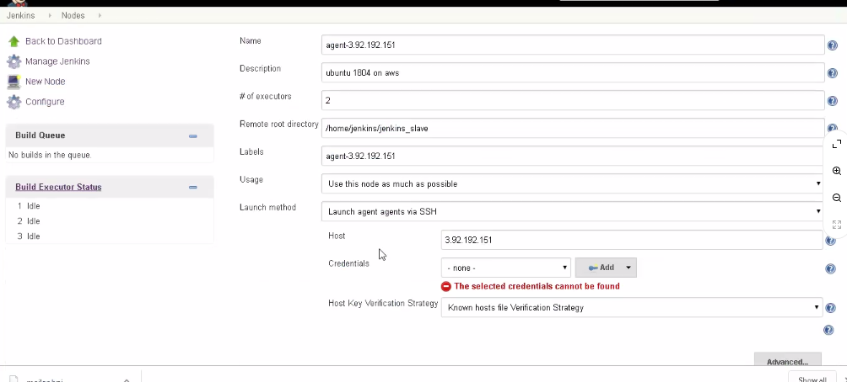

Create credentials: or add private key:

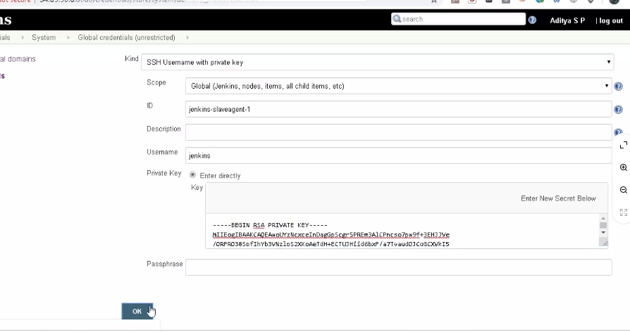



On freestyle project:

Run only master itself (restrict)

Run concurrent build if only required.

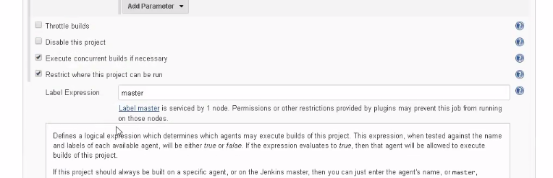

Run on parallel in single job:

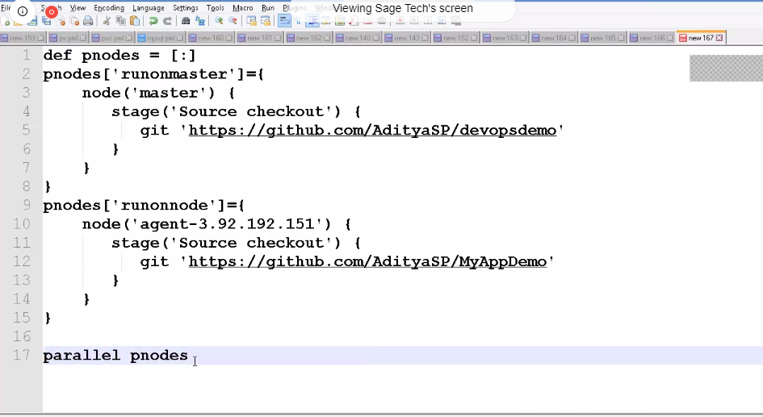

If you want to run different env.:

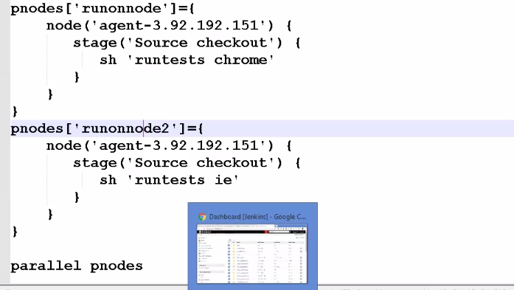

Dependent build:

Build Trigger After

Build will trigger if pipeline-prasoon is SUCCESS

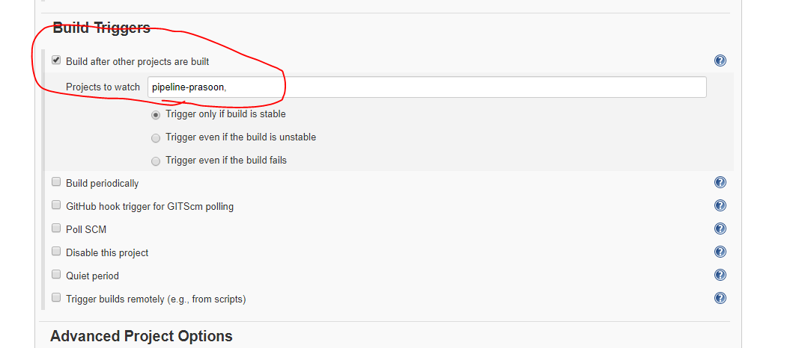

Copy artifact plugin>

Copy artifact from any successful build and move on any tarhet location, git, nexus, folder

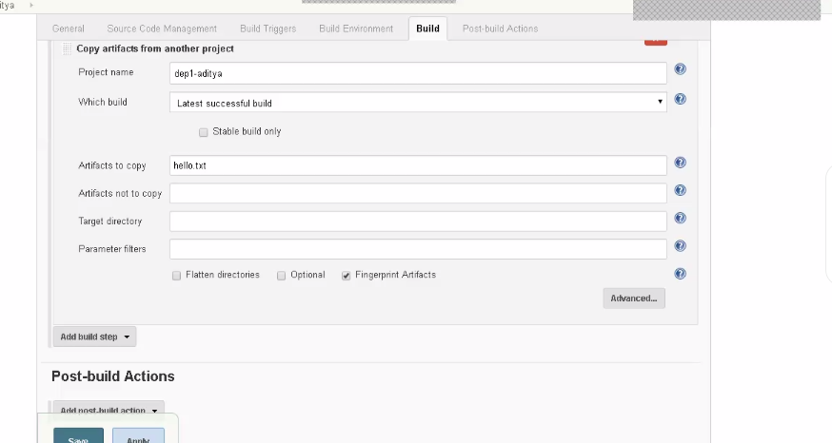

[maven-devops-demo1-1.0.1-SNAPSHOT.jar](http://54.89.90.6:8080/job/Prasoon_job_1/lastSuccessfulBuild/artifact/target/maven-devops-demo1-1.0.1-SNAPSHOT.jar)

docker installed

Docker:

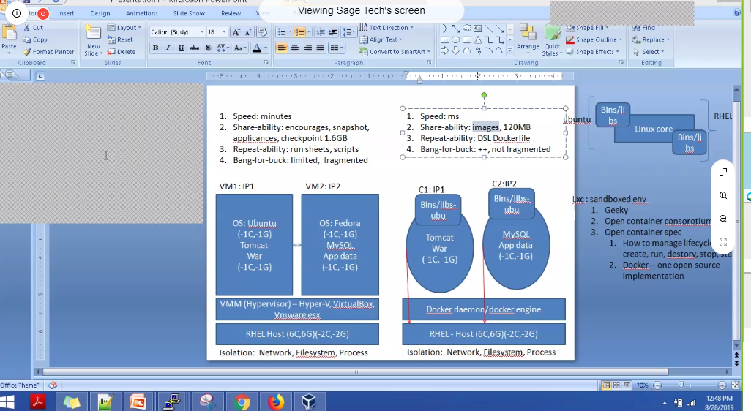

Docker cmd.

Hub.docker.com is the place you can find images of any s/w

Light weight VM=container

Httpd=apache in redhat

List your docker continer:

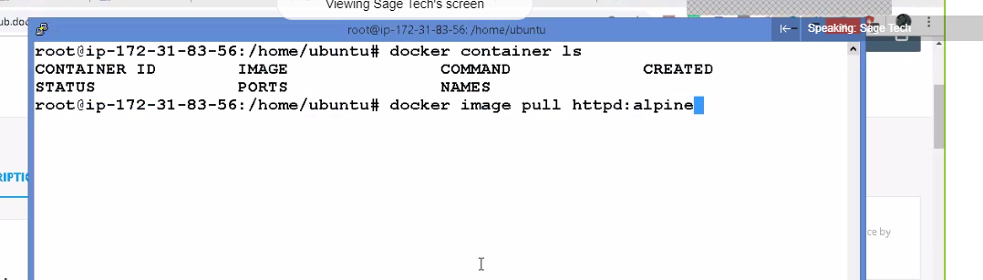

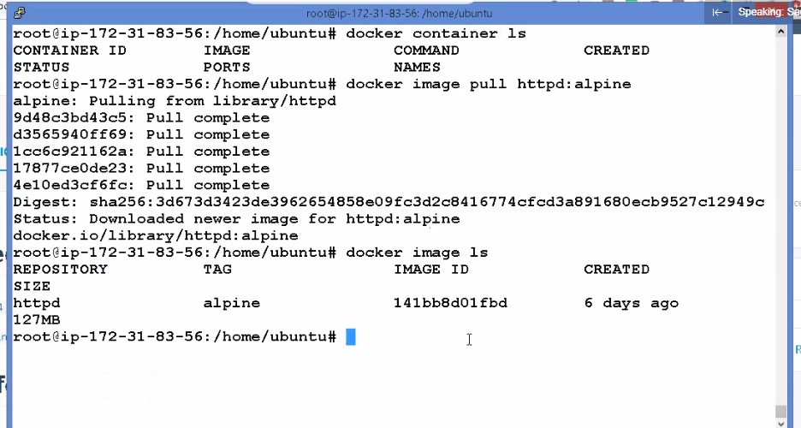

Container = process

Images are binary

Running the container:



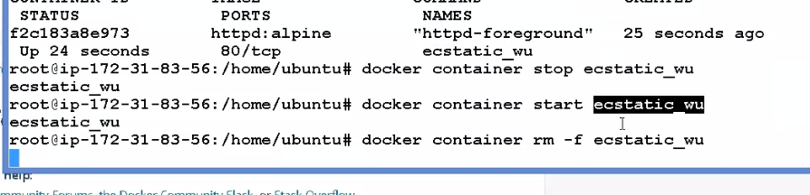

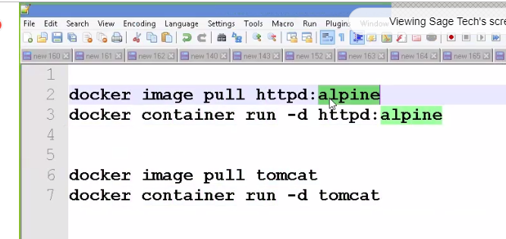

Pacakage your whole product/software and provide the img in docker

Docker continer networking:

3.92.192.151

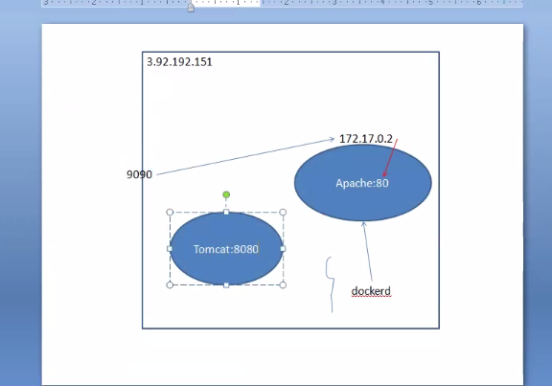

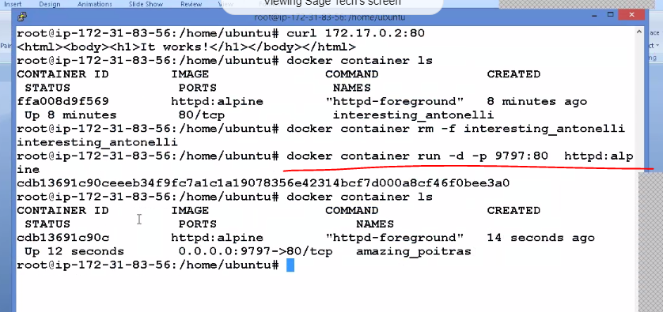

Jenkins itself if we can get as images continer

Docker install on Jenkins node

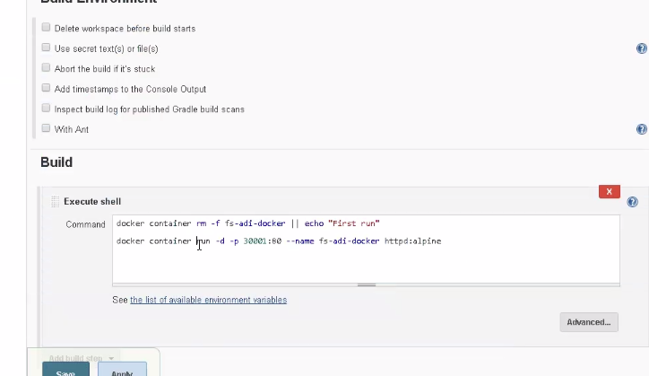

Adding Jenkins user in docker group:

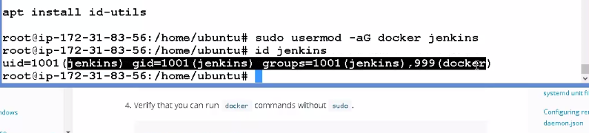

Creating contener images:

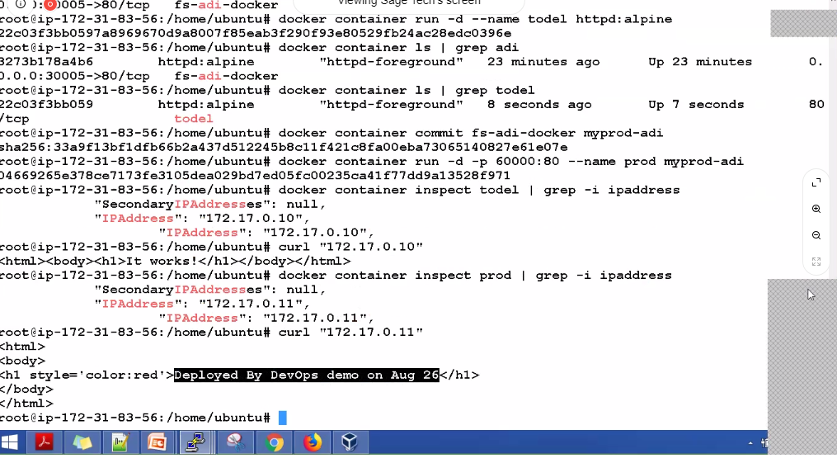

Docker container commit fs-adi-docker myprod-adi

Docker container ispect prod | grep -I ipaddress

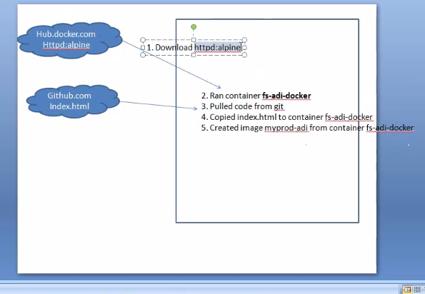

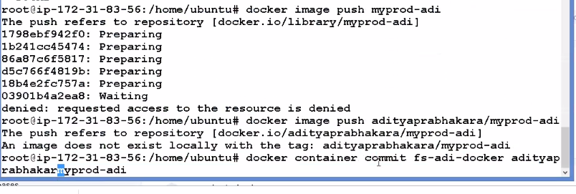

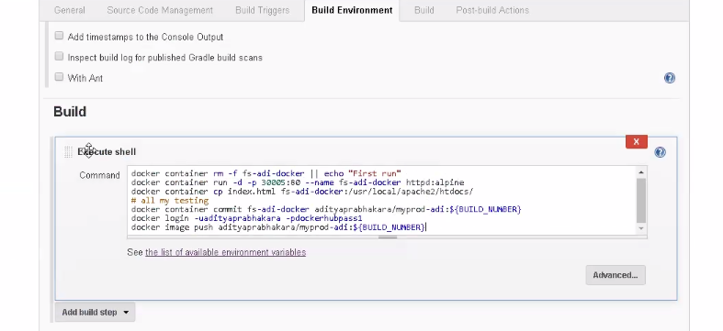

docker container rm -f fs-adi-docker || echo "First run"

docker container run -d -p 30005:80 --name fs-adi-docker httpd:alpine

docker container cp index.html fs-adi-docker:/usr/local/apache2/htdocs/

# all my testing

docker container commit fs-adi-docker adityaprabhakara/myprod-adi:${BUILD_NUMBER}

docker login -uadityaprabhakara -pdockerhubpass1

docker image push adityaprabhakara/myprod-adi:${BUILD_NUMBER}

docker push prasoon123/prasoongumasta:tagname

Ansible: also called as agent less system

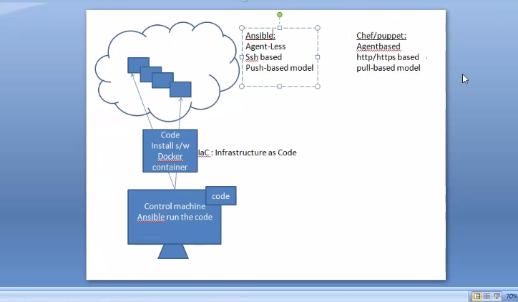

Installed Ansible on Master machine

Installed python on agent/slaves machines

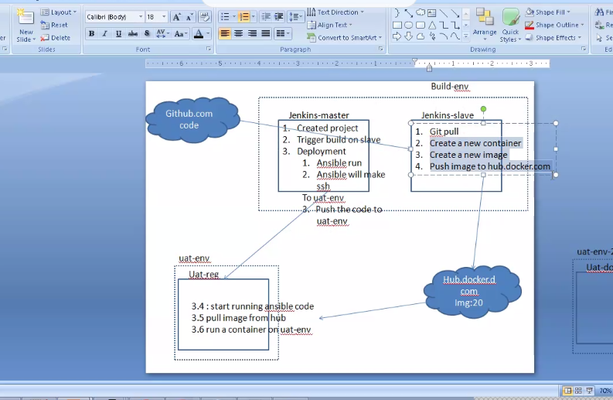

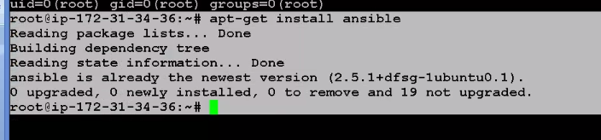

Github link for reference:

https://github.com/AdityaSP/itc-aug26-jenkins

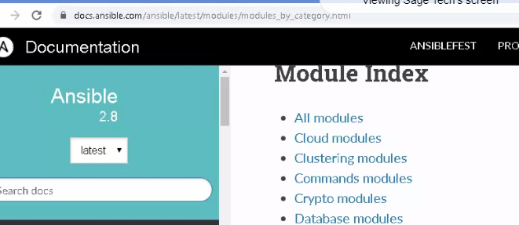

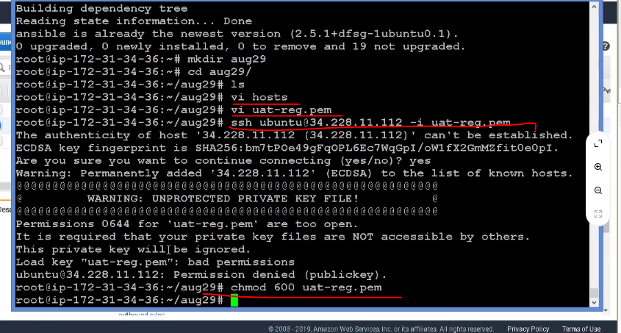

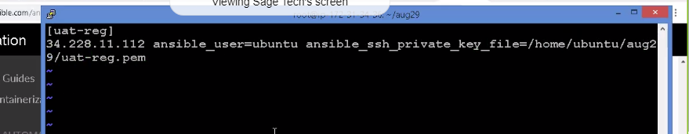

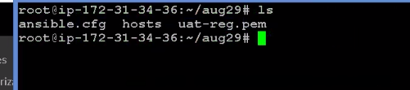

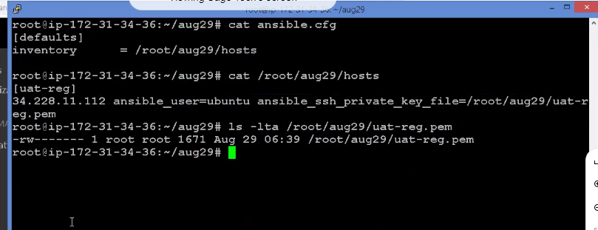

Inventory file/host file: list of all machines which we need to control

Conf file: the path of inventory file(where its actually located)

<https://yaml-online-parser.appspot.com/>

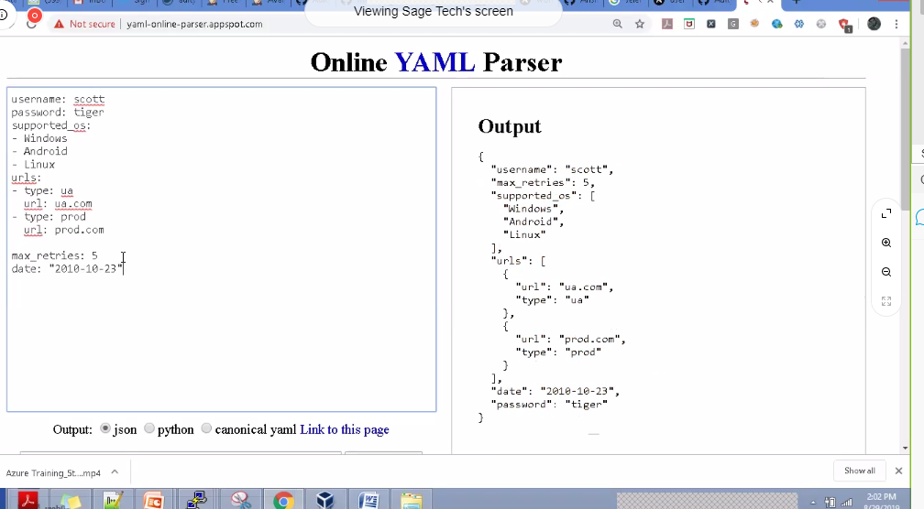

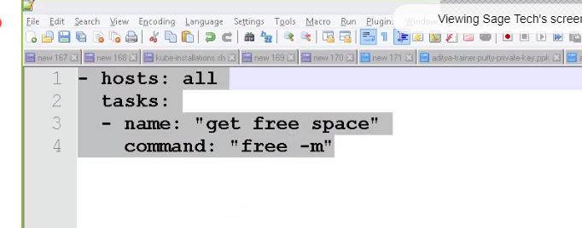

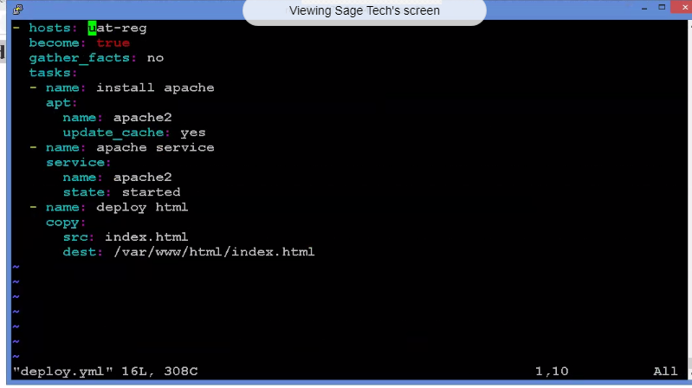

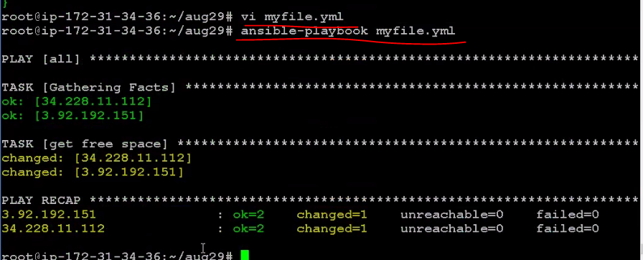

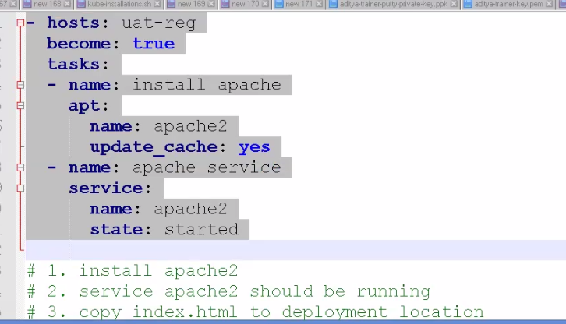

Conditional run on the basis of OS

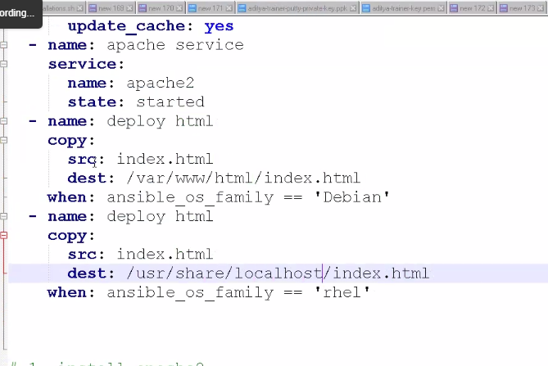

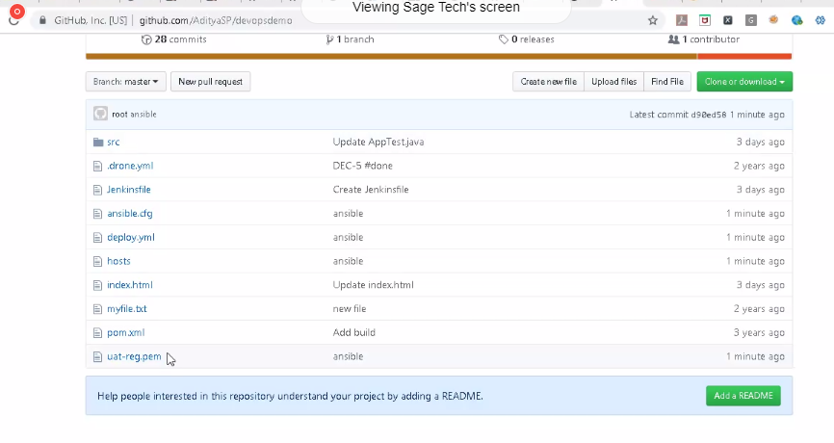

<https://github.com/AdityaSP/devopsdemo/>

chmod 600 uat-reg.pem

ansible-playbook deploy.yml

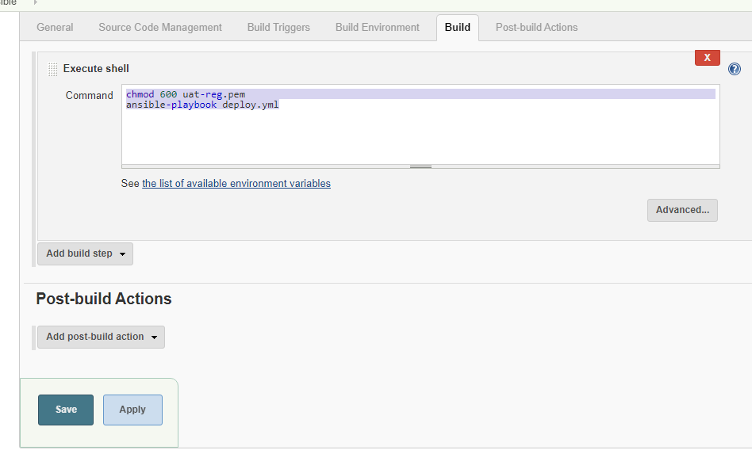



**Note:**

**If we want to directly run the jenkin build for each commit in github then we need to use webhook and set the Jenkins job url.**

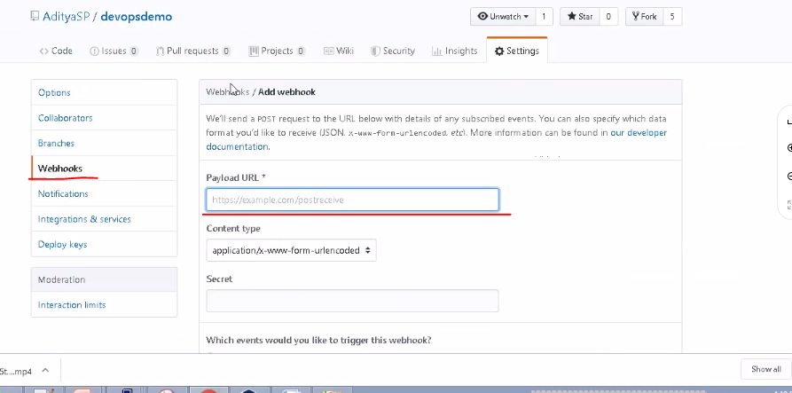

**And Upload URL :your Jenkins job**

**Idempodent**

**And convergence**

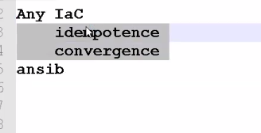

**Add Web HOOK:**



**Every time commit will happen in github, build will trigger**

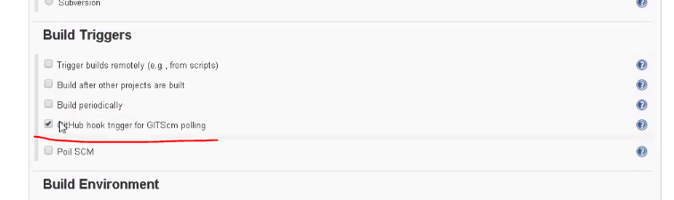



**SCM polling:**

**This will trigger after 15 min if any change in git**

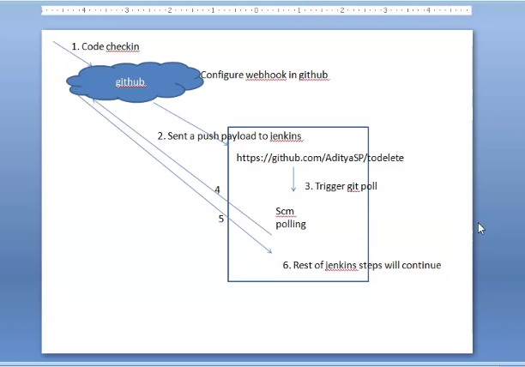

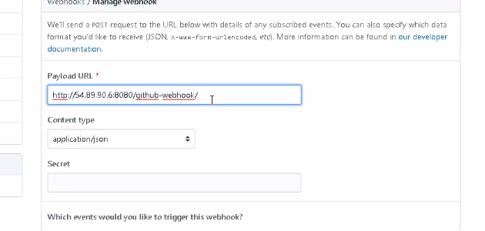

**In addition: Github server plugin (need to enter github url and credentials) will automatically create a webhook in github**

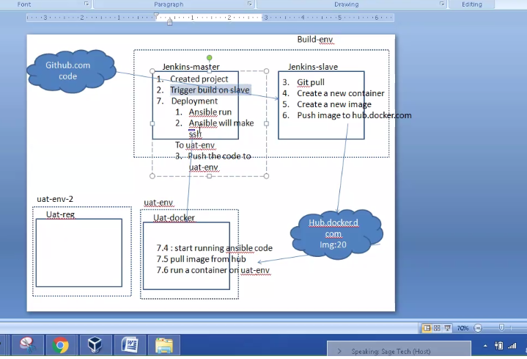

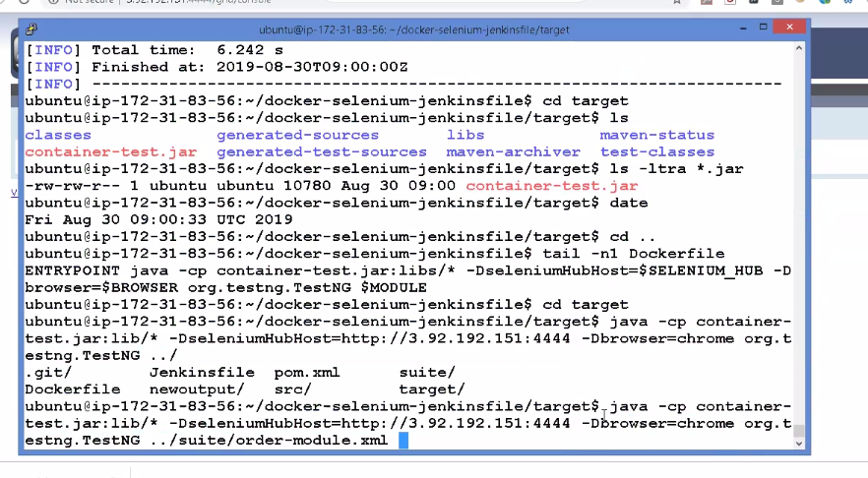

**Jenkins job:**

**Prasoon_docker:**

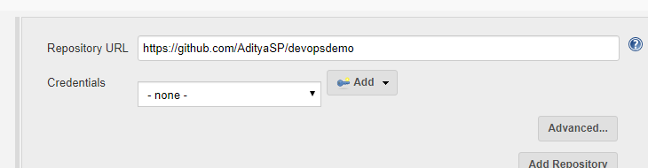

docker container rm -f fs-prasoon-docker || echo "First run11"

docker container run -d -p 50001:80 --name fs-prasoon-docker httpd:alpine

docker container cp index.html fs-prasoon-docker:/usr/local/apache2/htdocs/

docker container commit fs-prasoon-docker prasoon123/myprod-prasoon:${BUILD_NUMBER}

docker login -uprasoon123 -pJUly@2019

docker image push prasoon123/myprod-prasoon:${BUILD_NUMBER}

**Prasoon_ansible:**

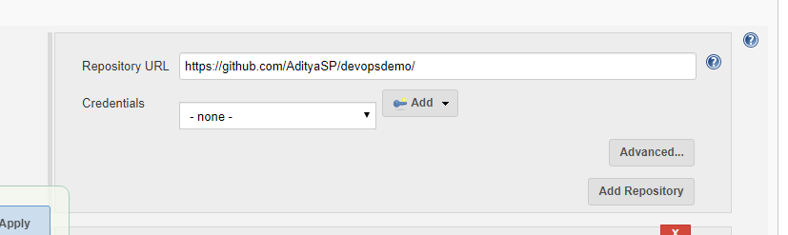

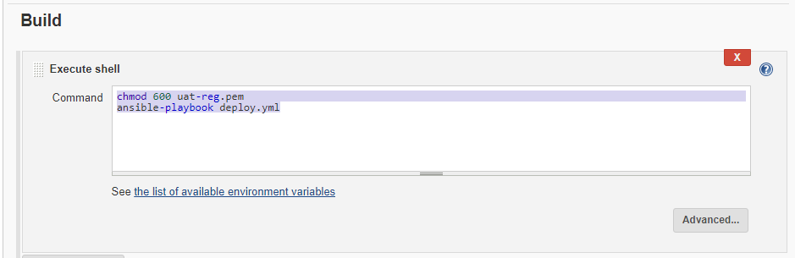

chmod 600 uat-reg.pem

ansible-playbook deploy.yml

**Prasoon_webhook**

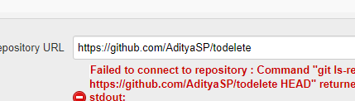

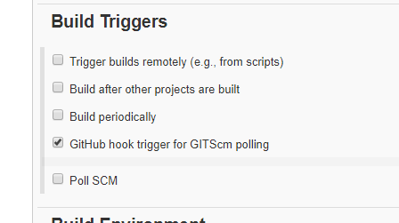

**Prasoon_job1:**

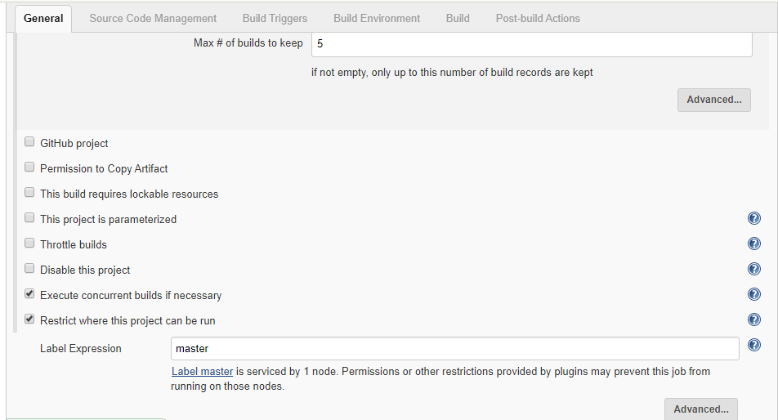

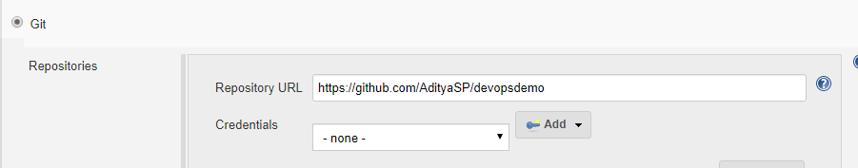

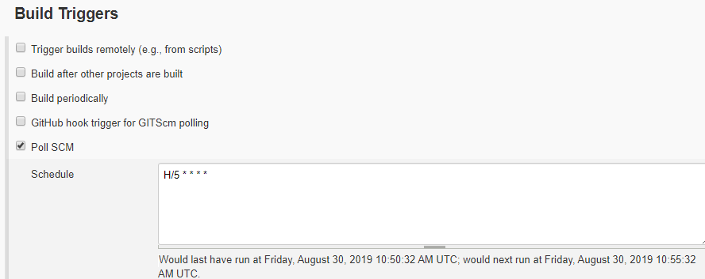

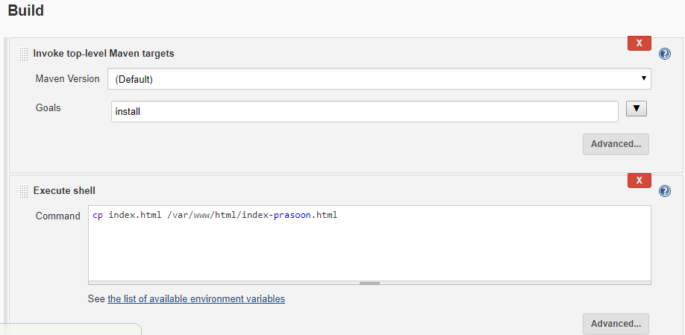

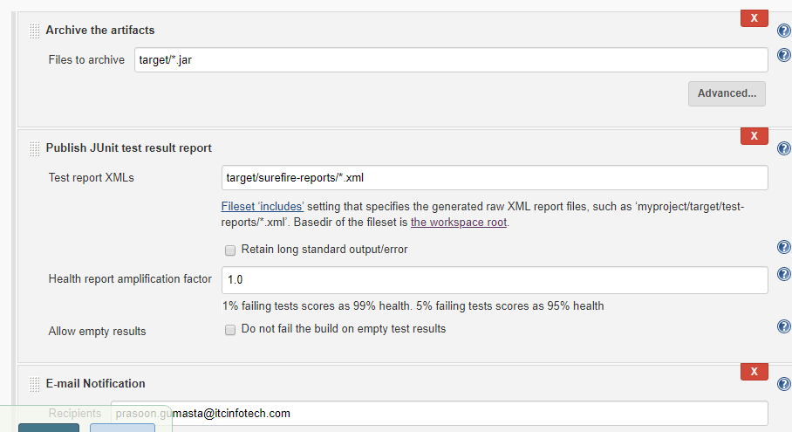

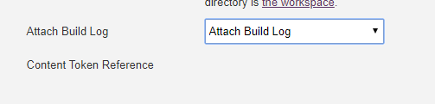

**Pipeline_prasoon:**

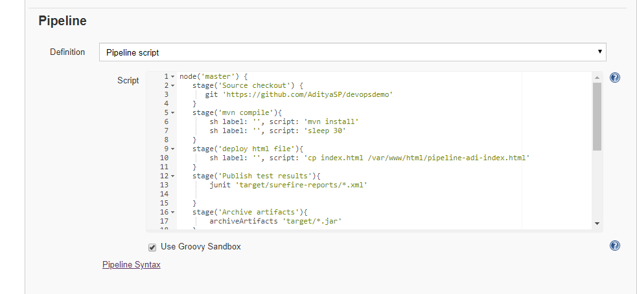

node('master') {

stage('Source checkout') {

git 'https://github.com/AdityaSP/devopsdemo'

}

stage('mvn compile'){

sh label: '', script: 'mvn install'

sh label: '', script: 'sleep 30'

}

stage('deploy html file'){

sh label: '', script: 'cp index.html /var/www/html/pipeline-adi-index.html'

}

stage('Publish test results'){

junit 'target/surefire-reports/*.xml'

}

stage('Archive artifacts'){

archiveArtifacts 'target/*.jar'

}

}

node('agent-3.92.192.151') {

stage('Source checkout') {

git 'https://github.com/AdityaSP/MyAppDemo'

}

stage('mvn compile'){

sh label: '', script: 'mvn install'

sh label: '', script: 'sleep 30'

}

stage('Publish test results'){

junit 'target/surefire-reports/*.xml'

}

stage('Archive artifacts'){

archiveArtifacts 'target/*.war'

}

}

**Full-ci-cd_prasoon:**

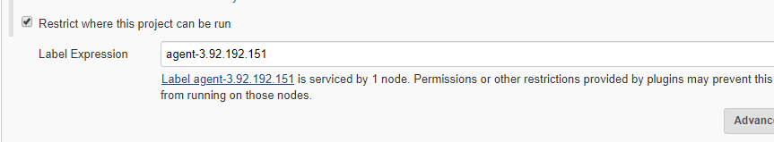

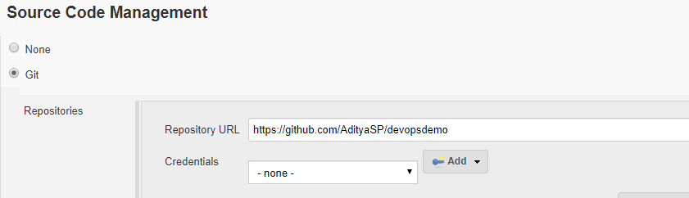

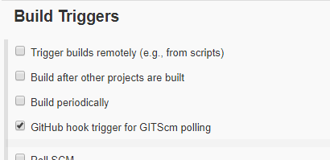

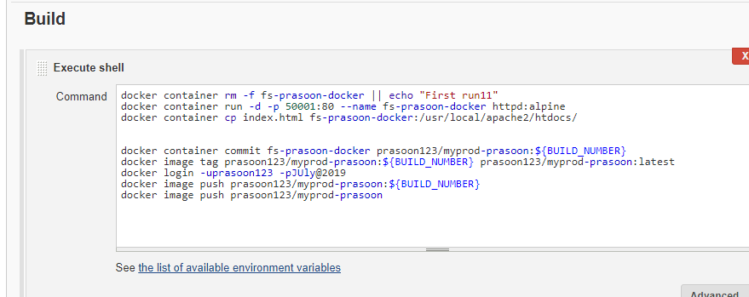

docker container rm -f fs-prasoon-docker || echo "First run11"

docker container run -d -p 50001:80 --name fs-prasoon-docker httpd:alpine

docker container cp index.html fs-prasoon-docker:/usr/local/apache2/htdocs/

docker container commit fs-prasoon-docker prasoon123/myprod-prasoon:${BUILD_NUMBER}

docker image tag prasoon123/myprod-prasoon:${BUILD_NUMBER} prasoon123/myprod-prasoon:latest

docker login -uprasoon123 -pJUly@2019

docker image push prasoon123/myprod-prasoon:${BUILD_NUMBER}

docker image push prasoon123/myprod-prasoon

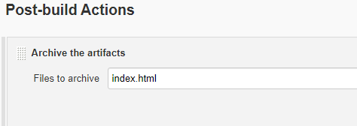

**pp-prasoon-pipeline:**

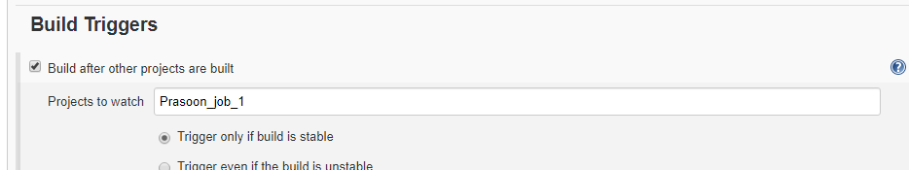

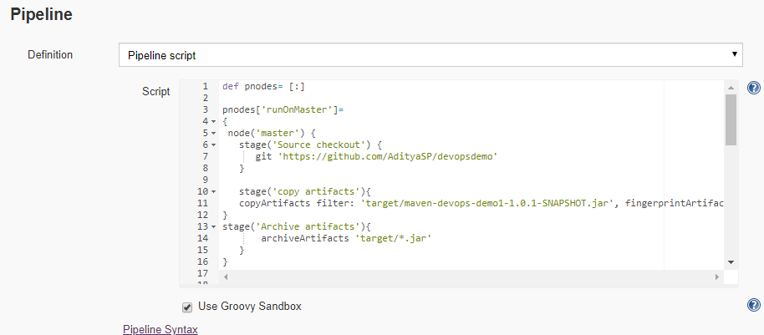

def pnodes= [:]

pnodes['runOnMaster']=

{

node('master') {

stage('Source checkout') {

git 'https://github.com/AdityaSP/devopsdemo'

}

stage('copy artifacts'){

copyArtifacts filter: 'target/maven-devops-demo1-1.0.1-SNAPSHOT.jar', fingerprintArtifacts: true, projectName: 'Prasoon_job_1', selector: lastSuccessful()

}

stage('Archive artifacts'){

archiveArtifacts 'target/*.jar'

}

}

}

pnodes['runOnAgent']=

{

node('agent-3.92.192.151') {

stage('Source checkout') {

git 'https://github.com/AdityaSP/MyAppDemo'

}

stage('mvn compile'){

sh label: '', script: 'mvn install'

sh label: '', script: 'sleep 30'

}

stage('Publish test results'){

junit 'target/surefire-reports/*.xml'

}

stage('Archive artifacts'){

archiveArtifacts 'target/*.war'

}

}

}

parallel pnodes

node('master'){

stage('send notification'){

emailext body: '$PROJECT_NAME - Build # $BUILD_NUMBER - $BUILD_STATUS',

subject: '$PROJECT_NAME - Build # $BUILD_NUMBER - $BUILD_STATUS', to: 'prasoon.gumasta@itcinfotech.com' }

}

**full-ci-cd-pipeline-prasoon-deploy**

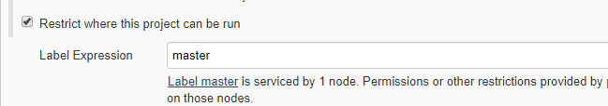

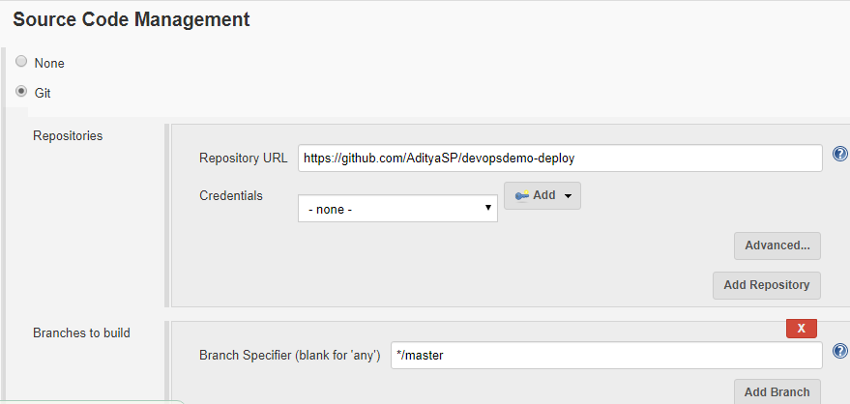

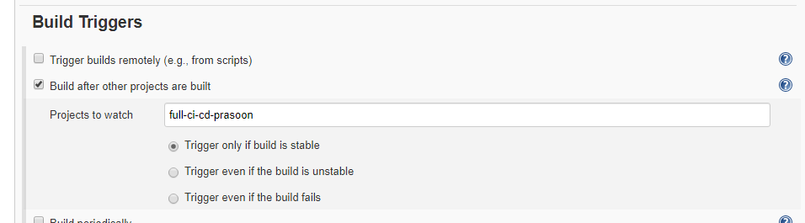

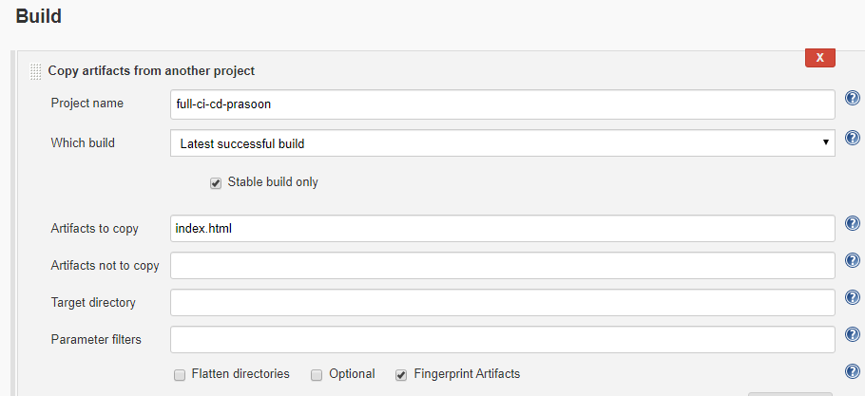

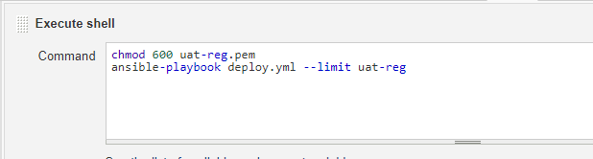

**full-ci-cd-pipeline-prasoon-docker-deploy:**

